SELECT empid FROM emp WHERE CAST ( hiredate AS DATE )='19/10/1998'; 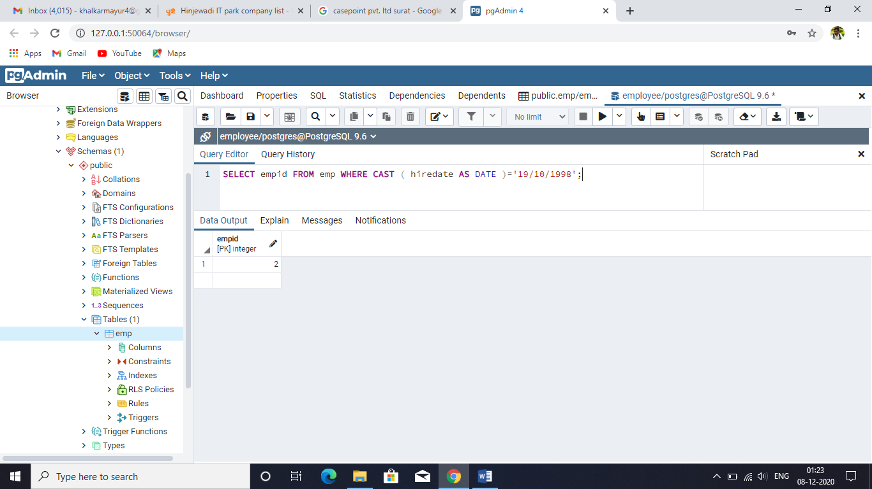

SELECT empid,ename from emp WHERE empid

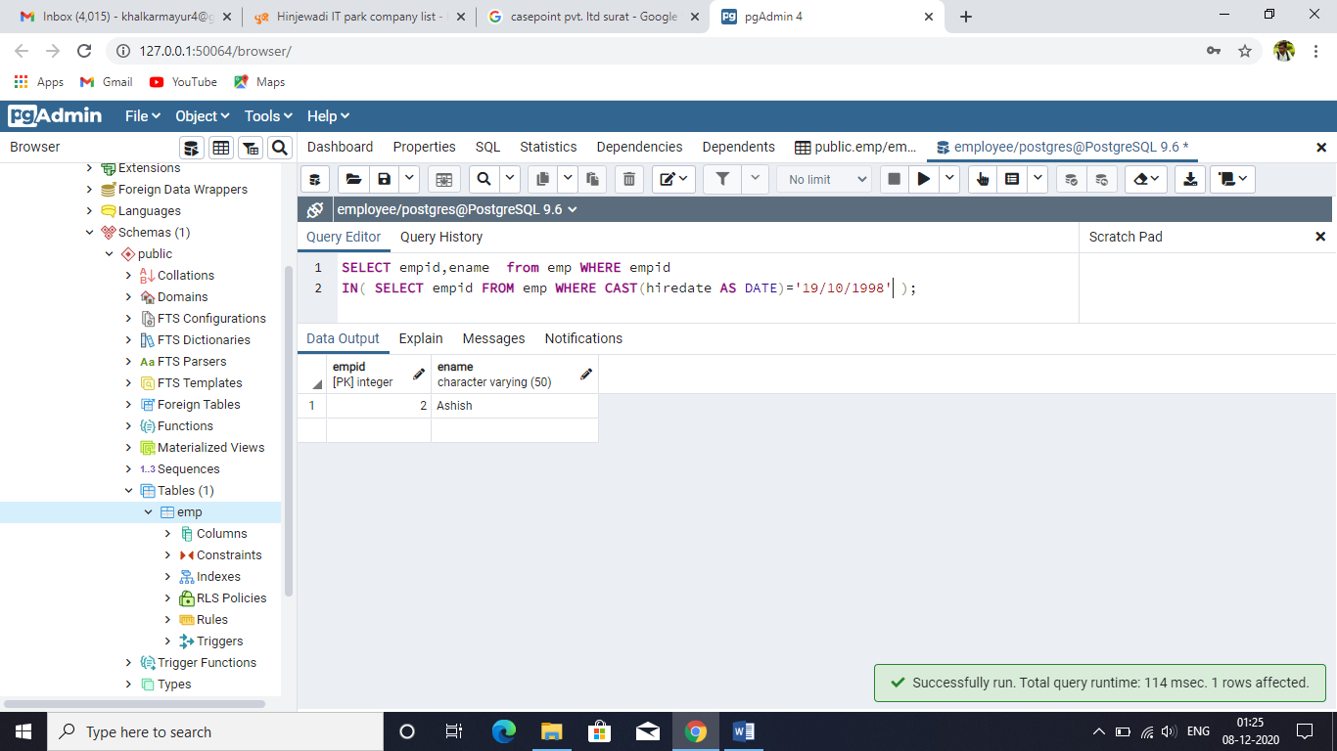IN( SELECT empid FROM emp WHERE CAST(hiredate AS DATE)='19/10/1998' );

SELECT empid , ename FROM emp WHERE sal BETWEEN 2000 and 3000; 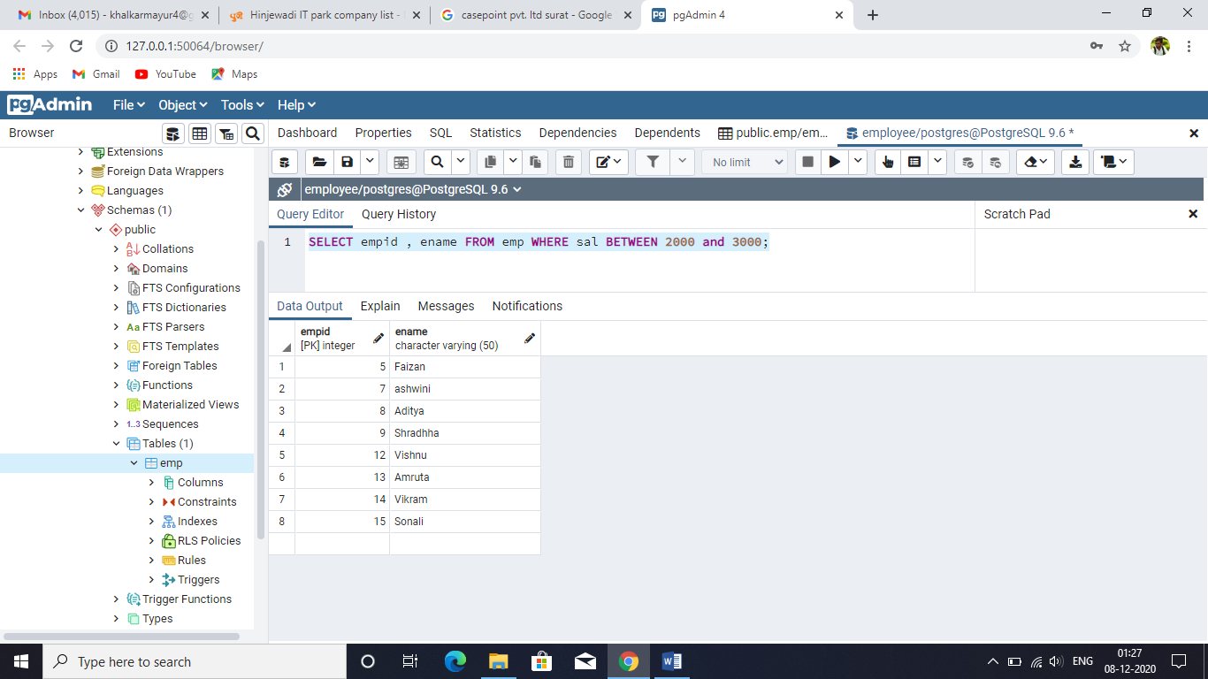

SELECT empid , ename FROM emp WHERE sal NOT BETWEEN 2000 and 3000;

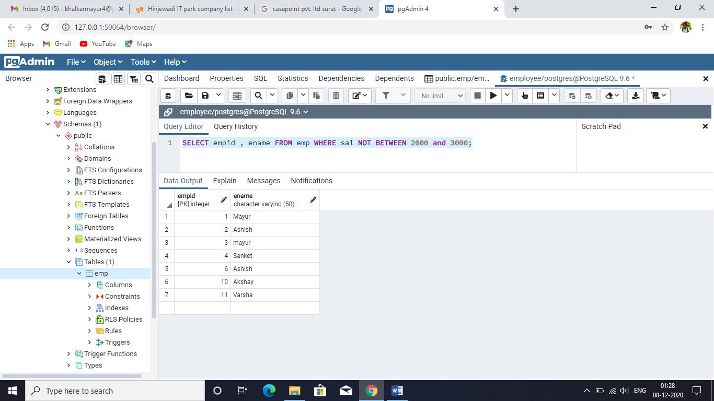

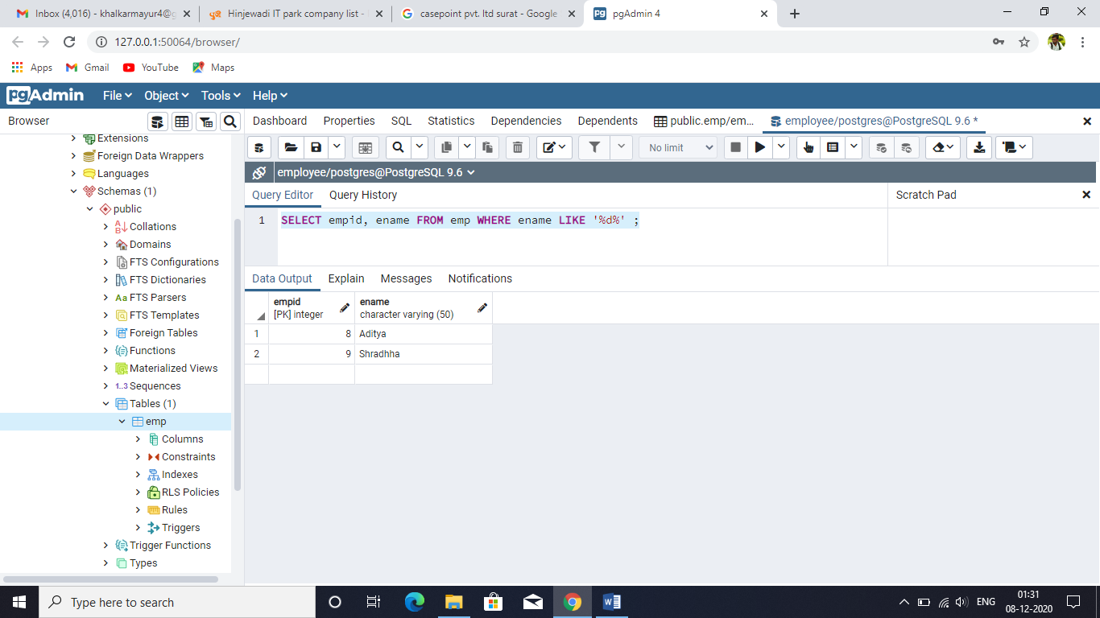SELECT empid, ename FROM emp WHERE ename LIKE '%d%' ;

SELECT empid, ename FROM emp WHERE ename LIKE 'M%' ;

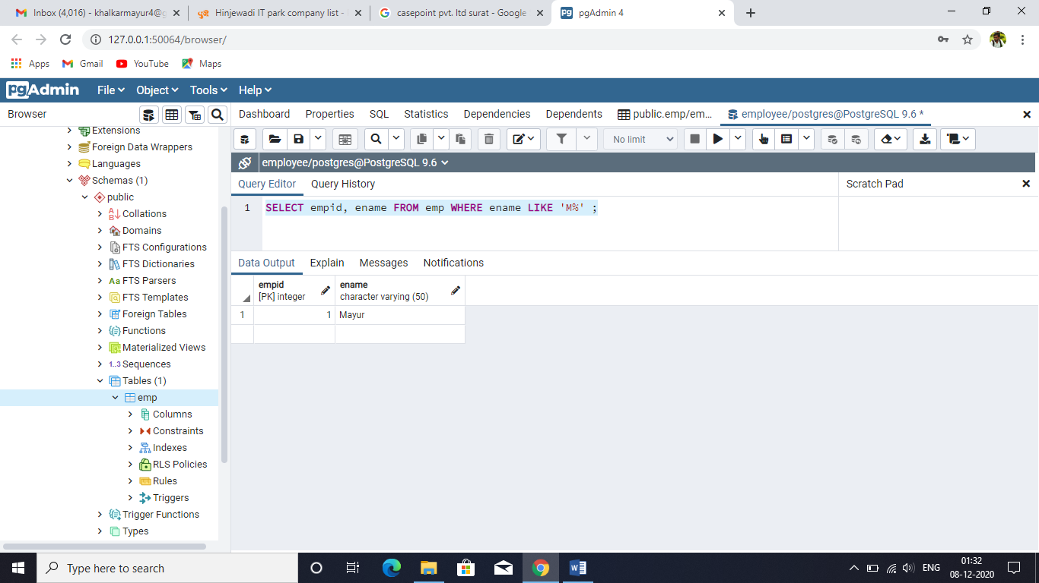

SELECT empid, ename FROM emp WHERE ename LIKE '_s%' ; 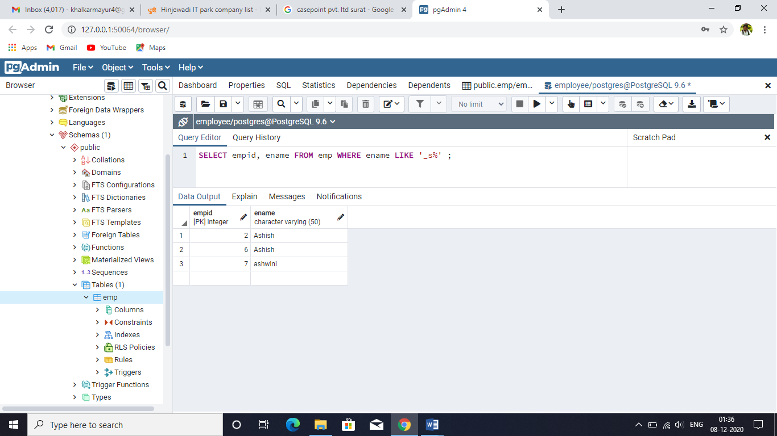

SELECT empid, ename FROM emp WHERE ename LIKE '_%' ;

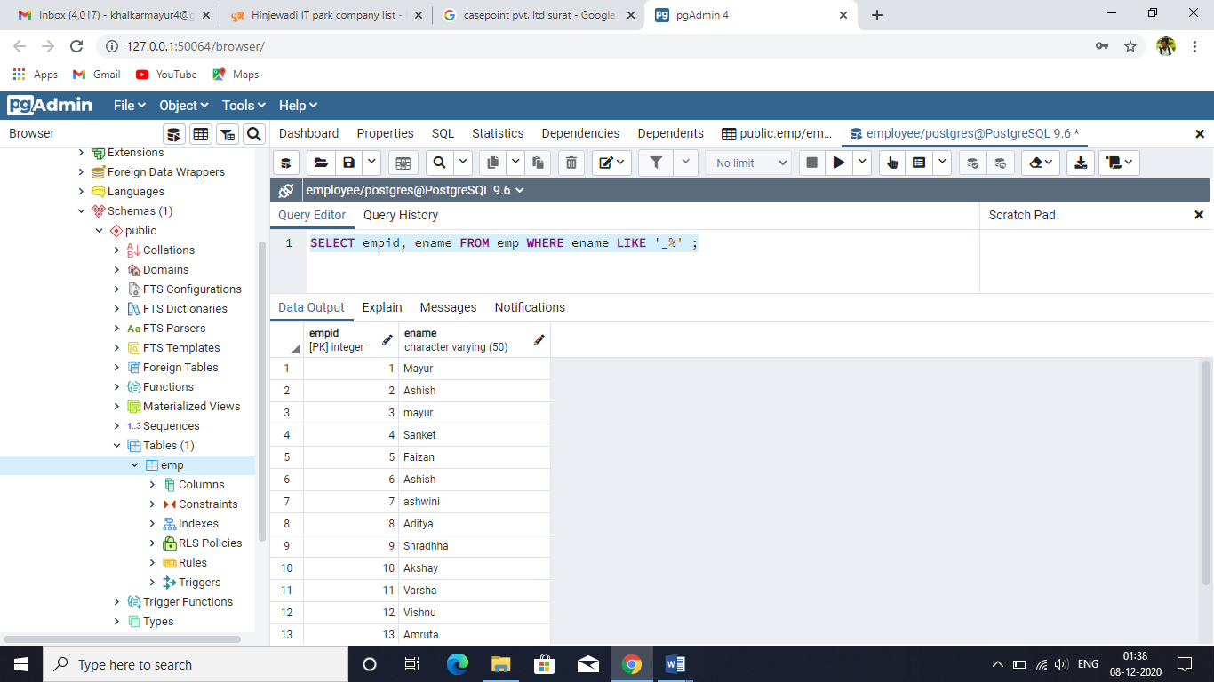

SELECT empid, ename FROM emp WHERE ename LIKE '%_nk%' ; 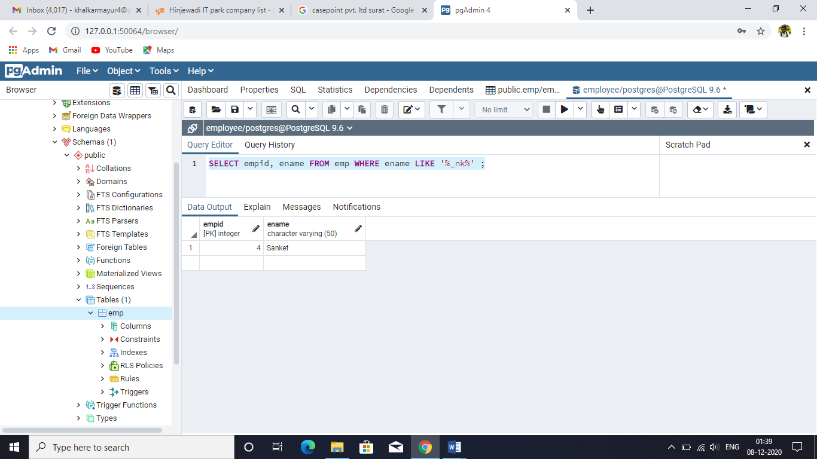

SELECT empid, ename FROM emp WHERE ename ILIKE '%YuR%' ;

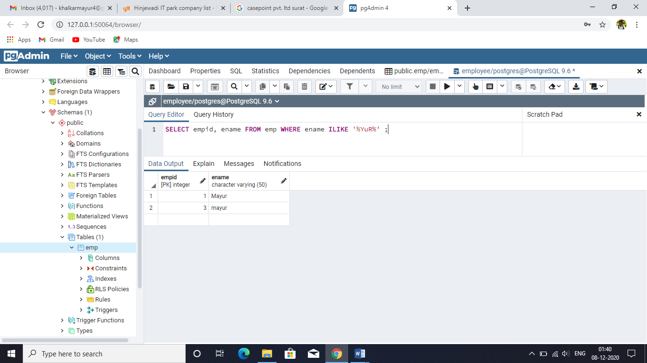

CREATE TABLE contacts (id INT ,first_name VARCHAR(50)

NOT NULL , Last_name VARCHAR(50) NOT NULL ,email VARCHAR(25) NOT NULL ,phone VARCHAR(15) ,PRIMARY KEY(id));

insert into contacts values(1,'Mayur','Khalkar','khalkarmayur4@gmail.com',9511787678); 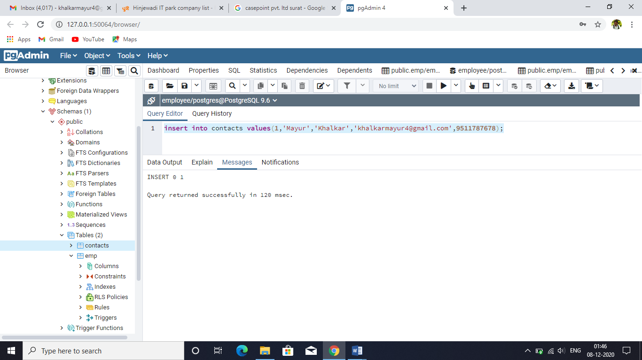

insert into con values(2,'Ashish','gaikwad','khalkarmayur4@gmail.com',NULL);

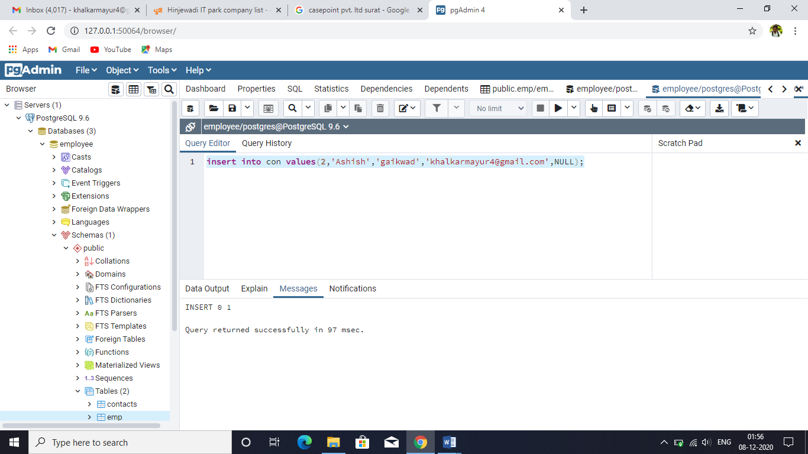

SELECT id,first_name,last_name,email,phone FROM con WHERE phone IS NULL; 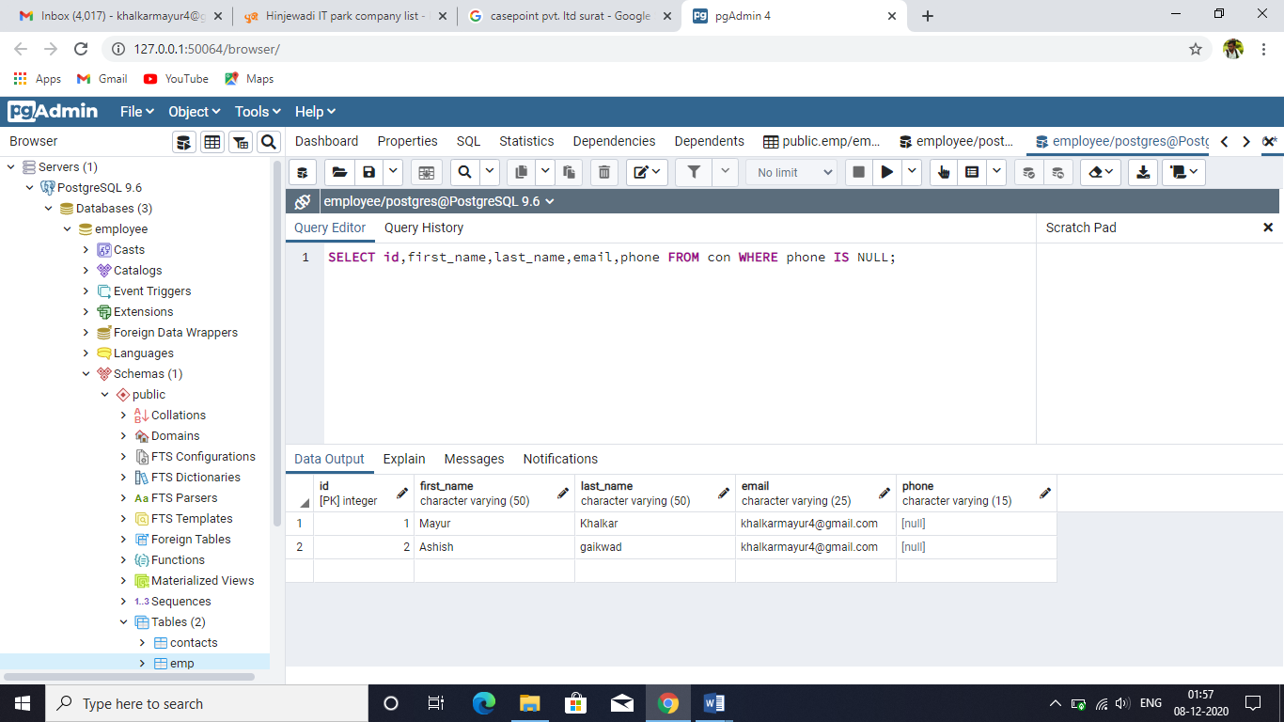

SELECT id,first_name,last_name,email,phone FROM con WHERE phone IS NOT NULL; 